Practical No. 5
Aim : Design given user Interface using various components such as Auto-layouts in the design tool
Name : Danish Altaf Solkar | Class : CO - B
Enrolment no. : 24111590805 | Batch : 2

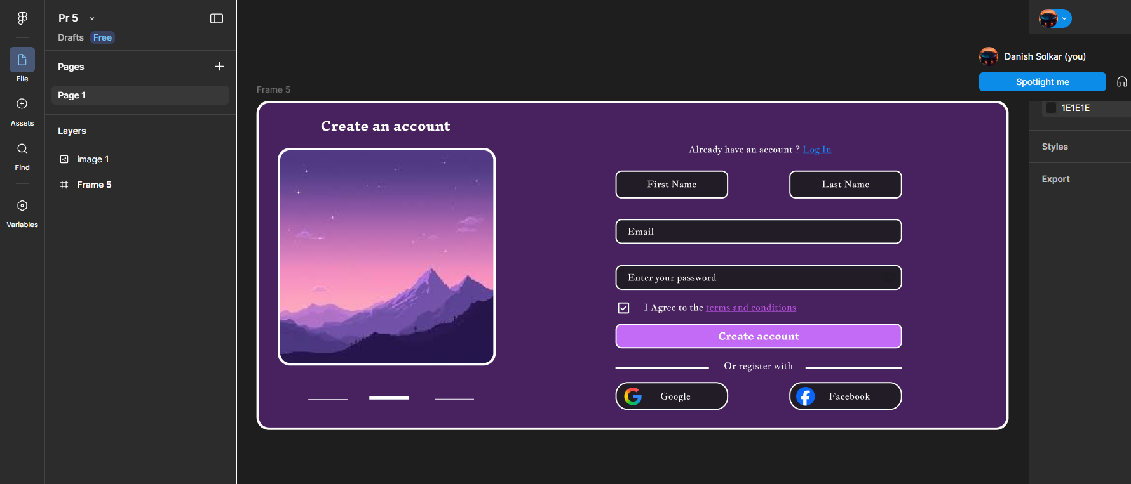

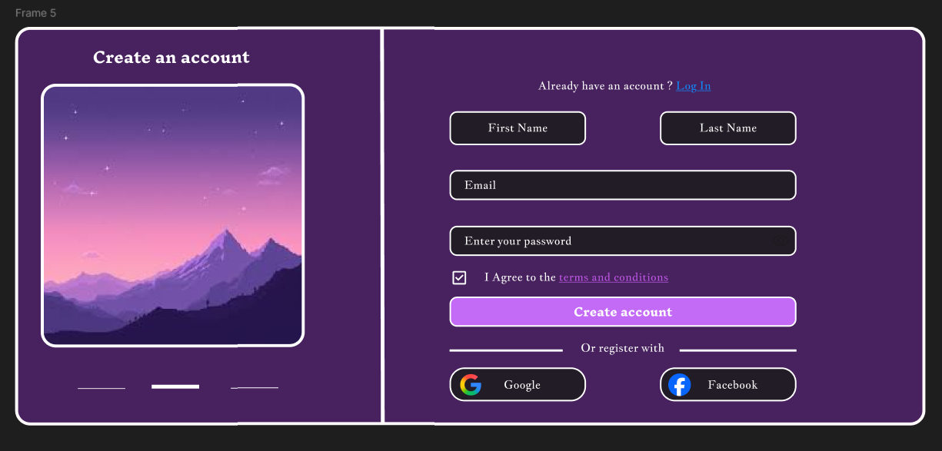
Process related  (15) | Product related  (10) | Total Marks  (25) | Signature

